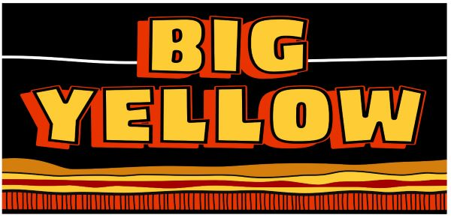

Participant Manual

Big Yellow Ltd Induction

Table of Contents

Welcome to Big Yellow! 4
Our Human Rights 5
Thermal Stress & Dehydration 5
Heat Stress / Heat Exhaustion 5
Heat Stroke --- is a medical emergency 5
First Aid 6
Heat Illness Risk Factors 6
Control Measures 6
Smoking 7
Mobile Phones 8
Digital Music Devices 8
Jewellery & Personal Adornment 9
Incidents & Accidents 9
Standard Operating Procedures 10
Job Safety Analysis 10
Safety Representatives & Toolbox Meetings 11
Safety Signs 12
Rights & Responsibilities 13
Duty of Care for Employees 13
Duty of Care for the Employer 13
Legislation – The Rules We Must Follow 13
On Mining Sites 13
On All Sites 13
At Campsites 13
When Flying 13
Manual Handling 14
Consider Work Environment 14
Safety Data Sheets 15
Electrical Testing & Tagging 15
Plant – Pedestrian Interface 16
Blasting Operations 17
Environmental Responsibility 18
Aboriginal Heritage Areas 19
Hydrocarbon & Environmental Management 19
Spills Management 19
Zero Harm Program 20
Our Objective: Zero Harm 20
Take 5 Assessment 21
Job Safety Analysis (JSA) 22
Assessing the Risk 23
What’s the Point? 24
Hierarchy of Controls 24
Hazard Observations 25
What a Good HAZOB Looks Like 25
Basic Fire 26
Classes of Fire 26
Fire Extinguishers 27
Fire Suppression Systems 28
Things to Consider Before Fighting a Fire 28
Fire Prevention 28
Reporting Emergencies 29
All Emergencies 29
Reacting to Emergency Calls 29
In the Event of a Fire 29
Personal Protective Equipment (PPE) 30
Minimum Site Safety Requirements 30
Uniforms 30
Eye Protection 31
Hard Hat 31
Hearing Protection 31
Gloves 32
Respiratory Protection 32

Welcome to Big Yellow!

Big Yellow Pty Ltd (Big Yellow) is a privately owned West Australian company.

We deliver a safe, enterprising and professional contracting service to the mining resources industry across Western Australia.

This book introduces you to the health, safety and environmental standards practiced at Big Yellow.

It provides you with the basic skills and knowledge about your work site and will assist you to work safely in protecting yourself and your fellow colleagues.

Big Yellow head office is at
1964 Albany Highway, Maddington, Western Australia

Everyone at Big Yellow is a Leader

Our Human Rights

Employees are entitled to be treated with fairness and respect in a safe and healthy workplace that is free from discrimination and harassment.

Big Yellow promotes and encourages a culture where all employees are proactively maintaining a safe and healthy workplace, including active promotion of safe work practices.

Unacceptable behaviours include:

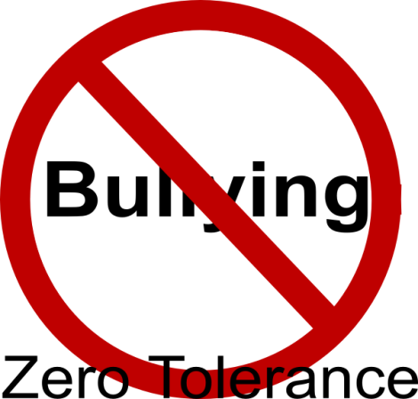
- Harassment and sexual harassment
- Unlawful and racial discrimination
- Bullying
- Victimisation

These behaviours will not be tolerated. All complaints are investigated.

Please refer to SOP6185 – Fair Treatment Flowchart and SOP3008 – Agreed Resolution of Issues for further information.

Thermal Stress & Dehydration

Thermal stress is preventable through addressing the risk factors and implementing control measures. Recognising the early signs and symptoms with use of prompt first aid may save a life.

Heat Stress / Heat Exhaustion
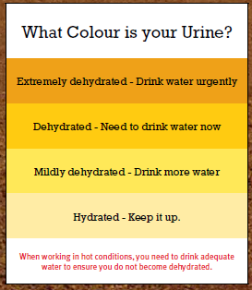
Symptoms include:

- Dizziness
- Nausea
- Tiredness / yawning
- Cramping

Heat Stroke --- is a medical emergency

Symptoms include:

- Hot dry skin
- Disorientation
- Delirium and convulsions
- Collapse
- Left untreated: death

First Aid

- Remove person to a shaded and cool environment
- Loosen any tight clothing
- If conscious: give small sips of cool (not cold) water
- Heat illness left untreated can be fatal - alert your supervisor immediately.

Heat Illness Risk Factors

- Not acclimatised
- Overweight
- Unfit
- Smoking
- Heart disease
- Certain medications
- Alcohol intake

Control Measures

- Schedule heavy work in the cooler parts of the day
- Take frequent rest pauses in cooler areas
- Maintain fluid levels – water and diet cordials are best; electrolyte replacement/sport drinks should be used sparingly
- Erect shade structures
- Increase air circulation
- Wide brimmed hat
- Long sleeved, collared shirt and sunscreen

Please refer to SOP3020 – Heat Stress and Dehydration for further information.

Smoking

All enclosed workspaces are smoke-free.

From the discussions you had in the induction, note down some examples here:

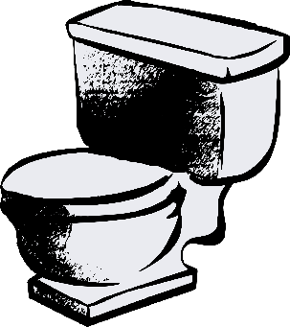
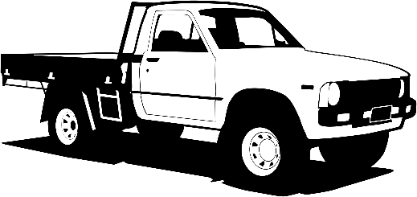
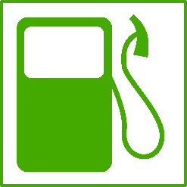
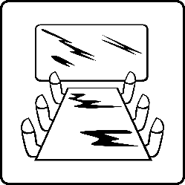
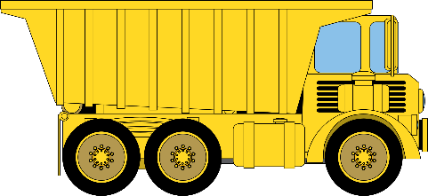
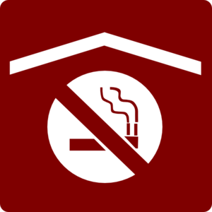

Mobile Phones

Personal and unauthorised mobile phones are not permitted on site.

Any unauthorised mobile phones found on site will be confiscated.

Should anyone need to carry their mobile phone during work hours, permission must be given by the Project Manager.

Site contact details can be obtained from site administrators so that family and friends can contact you in urgent situations.

Please refer to SOP3023 – Use of Mobile Telephones or Other Electronic Devices for further information.

Digital Music Devices
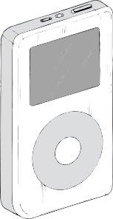
Ear/head phones may not be used on site as they hinder our ability to clearly hear two-way communications.

iPods and MP3 players can only be played by using a radio transmitter linked with the AM/FM radio.

Personal laptops, tablets and DVD players are not permitted on site. Please leave them in your room at camp.

Any digital music device being used with earphones will be confiscated.

Please refer to SOP3023 – Use of Mobile Telephones or Other Electronic Devices for further information.

Jewellery & Personal Adornment

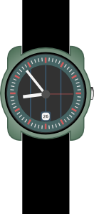
Items that are allowed to be worn whilst you are on site include:
- Watch with a pin-joining link (no Velcro)
- Medic-Alert bracelet
- Small ear/facial studs (no loops, hoops or dangling earrings)
- Neck jewellery / lanyards so long as they remain tucked inside shirts.
Wedding bands and other rings are NOT permitted to be worn on site, including if they are taped over. If you wish to keep it on your person, then it should be attached on a suitable neck chain and worn so it does not swing free of your shirt.

The only items that can be worn are the four (4) that are listed above.

Please refer to SOP3025 – Jewellery and Personal Adornment for further information.

Incidents & Accidents

All incidents and near misses need to be reported immediately to your supervisor.

All incidents and near misses are investigated. This is so we can prevent the incident from happening again (not to assign blame).

Equipment involved must be checked to ensure it is safe to use.

All injuries must be reported, regardless of how minor you think it is. Prompt treatment decreases the severity of an injury and stops it from getting worse. Qualified first aid persons will administer first aid on site.

First aid kits are located in all company light vehicles, crib rooms and site offices (where applicable).

An incident report form is completed for the following:
- Injuries
- Damage to equipment/property and fires
- Environmental hazards and impacts
- Near misses
- Non-conformances

Please refer to SOP3003 – Incident Reporting and Investigation for further information.

Standard Operating Procedures

Standard operating procedures (SOPs) are a written method outlining the correct way to conduct a particular task with regard to safety and the environment ---- they give the guidelines for doing a task.

It is important to know the guidelines that will help the task be done safely and effectively so we must review and understand an SOP before commencing a job.

If an SOP doesn’t exist for the job being undertaken, then a JSA needs to be done.

SOPs are located in the Big Yellow Management System and are accessible via computer.

It is your responsibility to be familiar with the SOP for the task that you do.

Job Safety Analysis

Job safety analysis (JSA) is the process of identifying potential hazards associated with a task, assessing their risk, and recording how to eliminate or minimise the risk of injury or damage through implementing safety controls.

A JSA is used for high-risk and non-routine tasks.

No tasks of high or extreme risk are to be conducted unless there is a SOP or JSA in place.

When completing the JSA consider the surrounding work environment, including other people as well as the task.

JSAs can be used as the basis for an SOP.
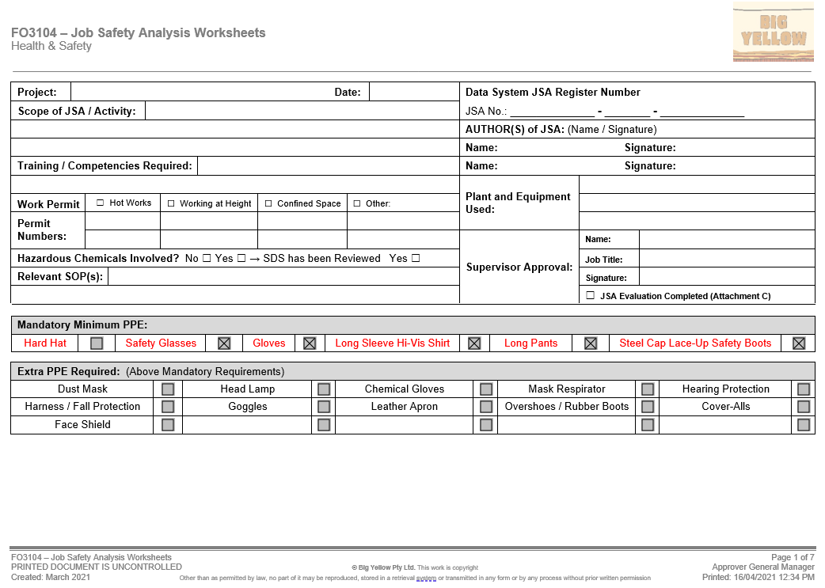

Safety Representatives & Toolbox Meetings

Big Yellow recognises and appreciates the contribution of safety representatives and rewards their efforts.

Safety representatives represent the crew on issues of safety, and they have certain powers as given by legislation. They are provided with training to conduct their tasks via an external provider.

Each crew elects a Safety Representative.

Safety representatives may:

- Inspect the workplace
- Investigate incidents, accidents and hazards
- Report hazards
- Refer matters to the safety and health committee.

Safety representatives under legislation cannot incur civil liability arising from their functions as a safety and health representative.

Everyone must attend a safety meeting at least once per month.

Safety meetings cover:
- Incidents and accidents over the past month
- Monthly safety topics
- Safety statistics (including medically treated and lost-time injuries)
- Hazards in the workplace
- Safety issues each person may wish to raise (or the safety representative on behalf of the employees)

Safety Signs

Safety signs must be obeyed at all times.

The following table highlights the different types of signs you may see around site.

Signage Type | Colour | Example
Mandatory | Blue and White | 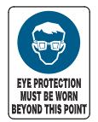  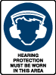  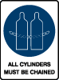
Prohibitory & Danger | Black, Red and White | 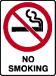  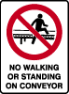  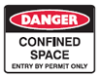  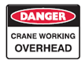
Warning | Yellow and Black | 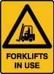  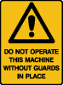  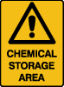
Emergency | Green and White | 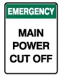  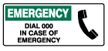  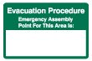
Fire | Red and White | 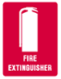
Hazchem | Different Colours | 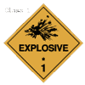  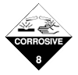

Rights & Responsibilities

Duty of Care for Employees

As employees, we must take care to:

- Ensure your own health and safety
- Avoid adversely affecting the safety and health of others
- Follow reasonable instructions from employer - if you don’t understand then ask questions
- Use PPE and safety equipment in the correct manner as instructed
- Report all incidents, accidents, injuries, hazards and near miss events.

Duty of Care for the Employer

Big Yellow must:

- Provide and maintain work areas, plant, equipment and systems of work so that employees are not exposed to hazards
- Provide information, instruction, training and supervision to all employees
- Consult and cooperate with safety representatives
- Provide employees with personal protective equipment (PPE)
- Ensure that employees are not exposed to hazards in the management of plant and substances

Legislation – The Rules We Must Follow

On Mining Sites

- Mines Safety and Inspection Act and Regulations (MSIA / MSIR)

On All Sites
- Explosive and Dangerous Goods Act and Regulations
- Dangerous Goods Safety Act and Regulations
- Electricity (Licensing) Regulations
- Environment Protection and Biodiversity Conservation Act
- Aboriginal Heritage Act

At Campsites
- Occupational Safety and Health Act and Regulations

When Flying
- Civil Aviation Act and Regulations

Breaching these laws is a criminal offence.

There are also Codes of Practice and General Exemptions which support the legislation.

Copies of these legislations are available to all personnel.

Manual Handling

All manual handling injuries are preventable.

Always use your Take 5 to assess manual handling tasks.

Wear gloves to prevent hand injuries.

Ask yourself the following questions:
- Do I really need to lift and carry this load?
  - Use lifting and moving devices wherever possible
- How heavy is the load?
  - Test the weight of the load to ensure the weight is within your strength capabilities
  - Check boxes are intact and not at risk of collapse
  - Consider a two-person lift
- Where is the load being lifted from?
  - Loads greater than 5kg should not be lifted from below knee level or higher than elbow level
- How often do I need to repeat this lift?
  - Frequent lifting and moving of loads increase the risk of injury
  - Plan the task: move the item once
- Do I need to twist or reach to lift and carry this load?
  - Twisting and bending with a load are common causes of injuries
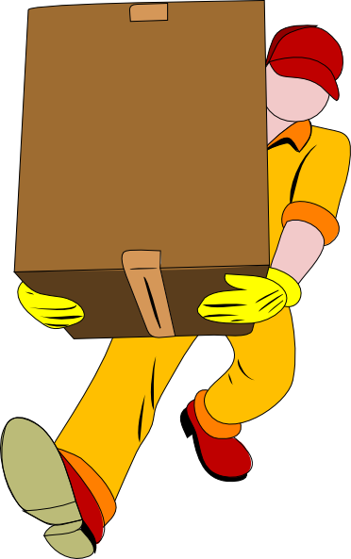
  - Set up storage areas to ensure items can be accessed readily

Consider Work Environment

- Clear path of travel
- Surfaces clean, dry, and free from trip hazards
- Steps and lips pose trip hazards: ensure you can see over the load

Please refer to SOP3007 – Manual Handling and Ergonomics for further information.

Safety Data Sheets

All chemicals on site have a safety data sheet (SDS).

The SDS contains information regarding:

- Chemical name and trade name
- Use or purpose
- Toxicity
- Emergency information
- Environmental impacts
- Spill clean-up
- Storage and transportation information
- PPE

SDSs are valid for 5 years; check the date to make sure you have the current version.

Before using the chemical, make sure to read the SDS and understand all of the requirements.

Electrical Testing & Tagging

High use electrical items are tested and tagged on a quarterly basis, but it is also important for you to inspect it each time you use it to make sure it is in good working condition.

Before using electrical items check that the tag is in date.

If you find any electrical equipment without a tag, or the tag is out of date, place an out of service tag on the equipment and immediately report it to your supervisor.

Only authorised electricians are permitted to work on electrical equipment.

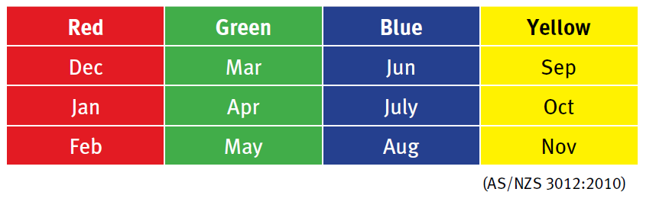
To remember the colours of the tags think “RuGBY”: Red Green Blue Yellow.
Also remember that Red starts with Summer

Plant – Pedestrian Interface
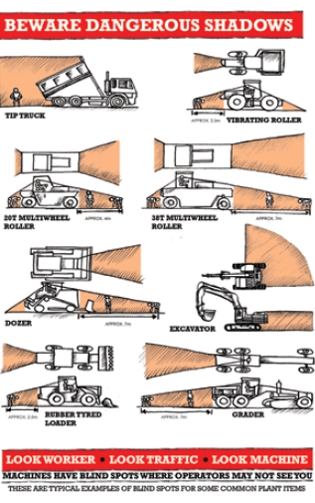
Personnel required to work in the vicinity of plant are to exercise caution.

Working around plant is a high risk activity.

The following points are to be adhered to at all times and are mandatory on all sites:

- Never assume the operator has seen you
- Never walk behind items of plant
- Be aware of blind spots on machines
- Maintain a safe preparation distance between you and the plant
- If required to work closely to plant, ensure that you have an understanding with the operator (maintain positive two-way communication)
- Make eye contact and wait until the machine has come to a complete stop and implements have been lowered before approaching

Operators must:
- Ensure reversing alarms are working at all times. If the alarm is not working the machine is to be tagged “out of service” and not operated until the fault has been repaired
- If in doubt as to the whereabouts of ground personnel, stop the machine
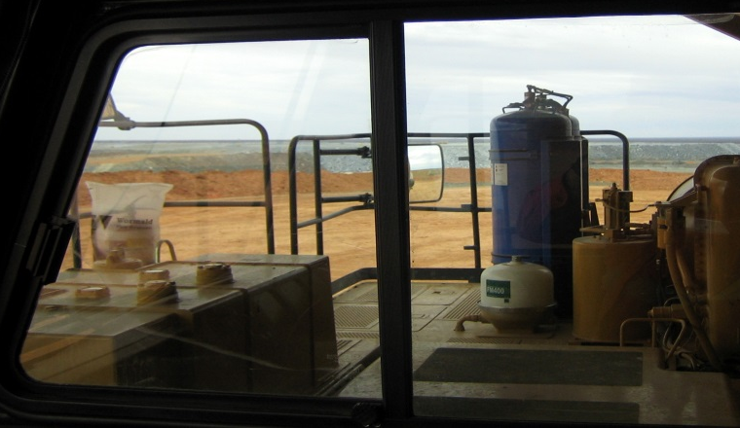

Blasting Operations

Blast areas, magazines and the magazine compound are restricted areas and access is restricted to authorised personnel only.

On the day a blast is to occur, the information is written on the blast board and shared at pre-start information (PSI) meetings.

Take note of blasting times as you may be required to vacate your work area when a blast is in progress.

There are two types of cones used in blasting operations.
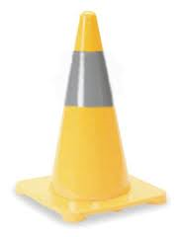

Yellow cones with a reflective stripe are used to demarcate blasting areas. You must gain permission from the Shotfirer to access these areas.

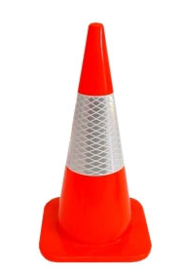

Orange cones with a reflective stripe are used to demarcate and restrict access. You must gain permission from the relevant supervisor for the area concerned.

For Drill & Blast areas, contact the Shotfirer, Drill & Blast Supervisor or the Driller.

Environmental Responsibility

Caring for the environment is a shared responsibility between Big Yellow, employees, the clients we work with and contractors.

An environmental impact is defined as any change to the environment, whether adverse or beneficial.

Environmental hazards must be reported.

From the discussions you had in the induction, note down some examples of environmental hazards here:

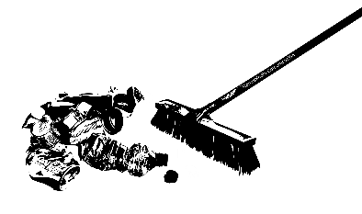

Aboriginal Heritage Areas

The Aboriginal People have rights and interests in land according to their traditions and customs.

The Traditional Owners recognise historical and current sites significant to their culture.

These sites are protected under the Aboriginal Heritage Act (1972) and penalties exist for anyone who disturbs those sites.

Big Yellow acknowledges the diversity of Aboriginal cultural heritage and shows respect for sites of significance to Aboriginal People.

Hydrocarbon & Environmental Management

Hazardous waste must not be taken to landfill.

Where site has the ability to recycle – do so.

Find a use for waste material.

If you are not sure where to dispose of an item, ask your supervisor.

We can reduce environmental impact by:

- Turning off lights when not in use
- Keeping doors and windows shut when running air conditioners
- Not littering
- Keeping to designated tracks and roads
- Not feeding, approaching or otherwise encouraging native and feral animals
- Washing down equipment

Spills Management

All hydrocarbon spills must be cleaned up using the correct equipment.

Any hydrocarbon spill of 5 litres or more must have an incident report form completed.

Spill response procedure:

Control --- turn off valves, pumps, etc.
Contain --- prevent the spill from spreading
Clean up --- dispose of material in the designated bin or bioremediation facility as appropriate

Spill kit materials are kept in yellow wheelie bins. They are located in areas where hydrocarbons are stored (e.g. workshop, fuel farm, service truck, etc.).

Report and fix any leaks or faulty equipment, don’t discount the impact a small leak can have over time.

Hydrocarbons are toxic to the environment and must be stored in bunded areas. Ensure bunds do not overflow with rainfall and are large enough to contain the volume plus 10% (i.e. 110% of the product being stored in the bunded area).

Zero Harm Program

The aim of the Big Yellow Zero Harm goal is to encourage safe behaviour.

Safe behaviour leads to injury and incident prevention.

All personnel must adopt proactive safety values and attitudes that reflect a good safety culture for prevention of injury and incidents to be achieved.

We achieve this through a variety of initiatives (e.g. Take 5 assessments, reporting hazards and incidents, and completing JSAs).

All of these initiatives are important tools to meet our objective of “Zero Harm”.

Our Objective: Zero Harm

Big Yellow is committed to the elimination of all work related injuries and incidents involving all people associated with our activities.

No business activity comes before health and safety.

Our commitment and objective is Zero Harm to our people and equipment --- a workplace that is free from injuries and incidents.

To achieve this, Big Yellow will show total commitment from its leadership and cooperation from employees in pursuing the target towards Zero Harm.

Big Yellow will also develop and evolve strategies to ensure proactive commitment to safety and to ensure it is culturally entrenched across the whole workforce.

Take 5 Assessment

A take 5 form is a safety tool purposely designed for workers to identify health and safety hazards before starting any work in worksites. Contractors and workers can quickly mitigate exposure to hazards and other health risks when they conduct health and safety checks with the general Take 5 procedure, i.e., stop, look, assess, make safe, complete. This 5-minute safety process is primarily done to prevent possible near misses, injuries, and accidents.

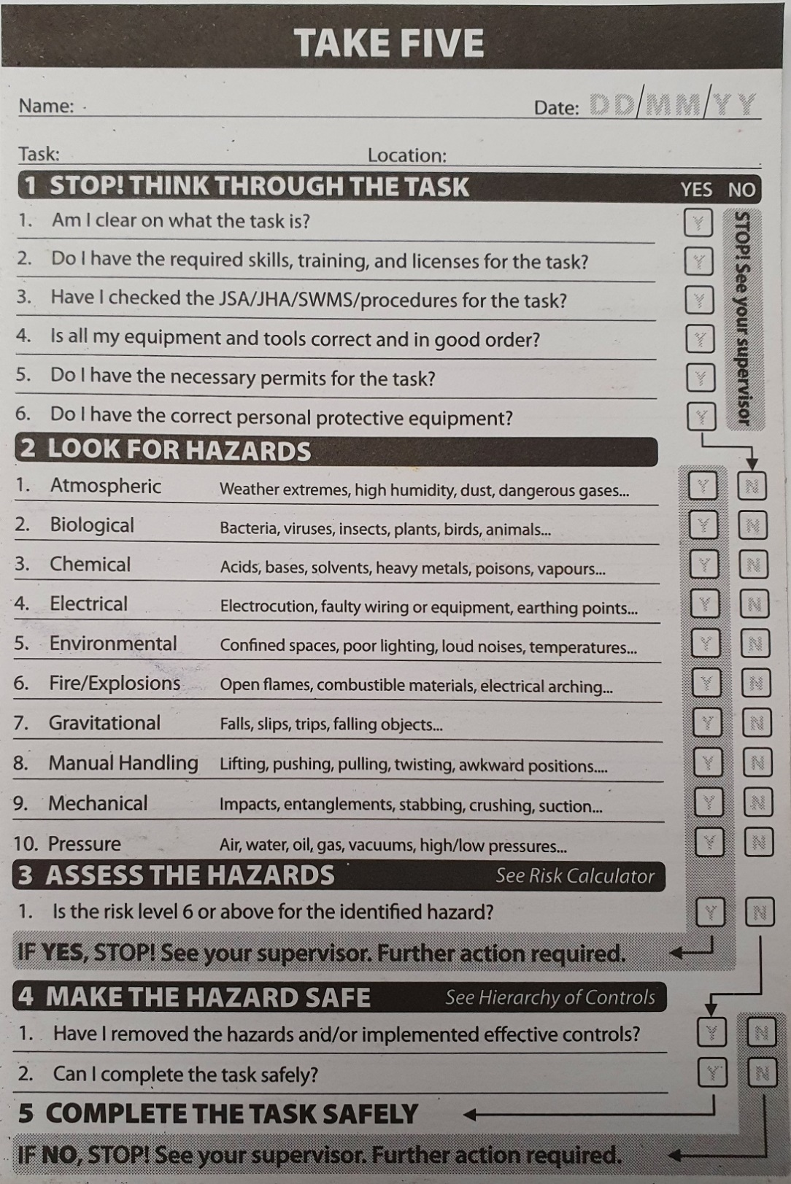

Job Safety Analysis (JSA)

If you identify a task as a ‘high’ or ‘extreme’ risk then you must consult your supervisor and complete a JSA for the task. Often you will hear it referred to as a JHA, this is the same thing.

A JSA is a useful tool for observing and breaking down high-risk tasks into individual steps and recommending controls. Supervisors and employees work together in accomplishing JSA templates to ensure that both have a good understanding of the hazards and come up with safety measures.
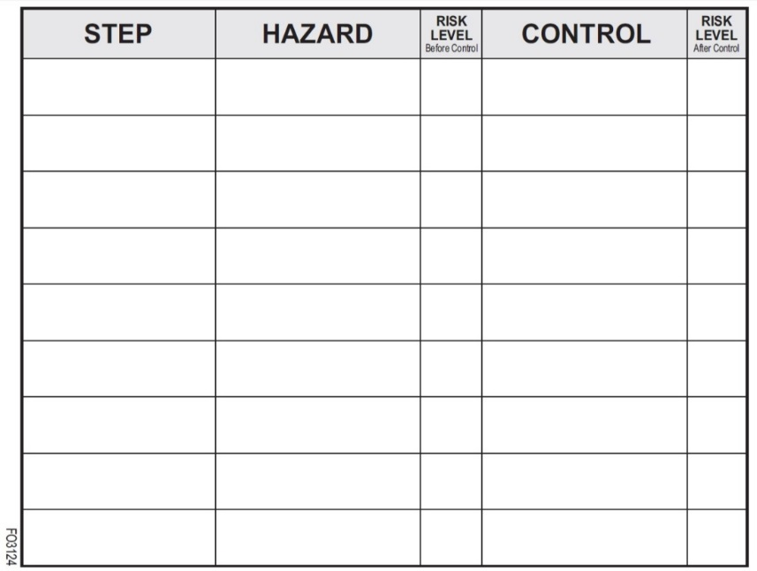

Assessing the Risk

Risk assessment is determining the likelihood (possibility) and consequence (outcome) of incidents occurring.

The following tables provide a description for the likelihood and consequence measures.

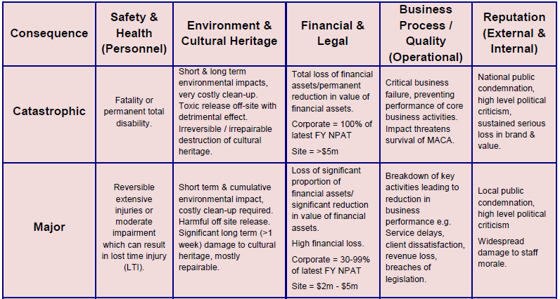
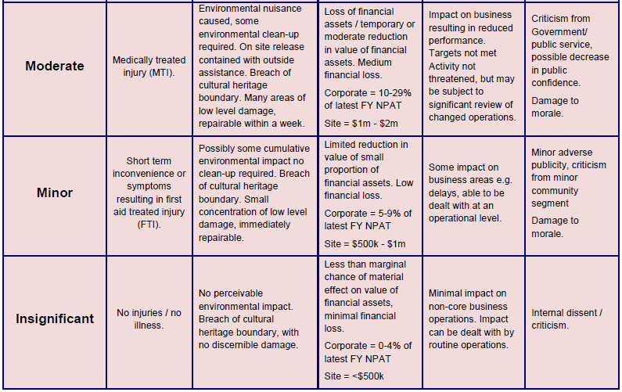

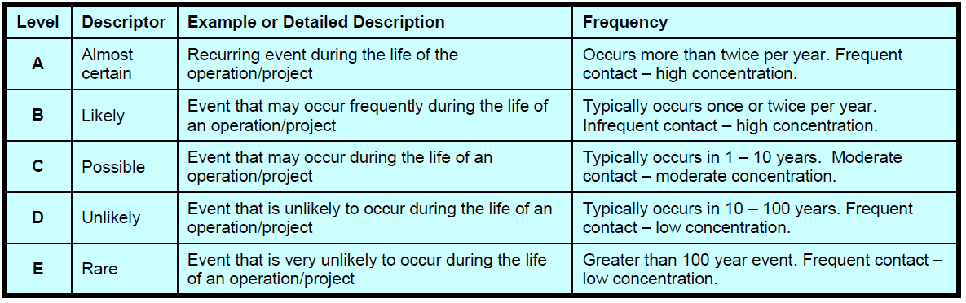

The risk matrix we use at Big Yellow:

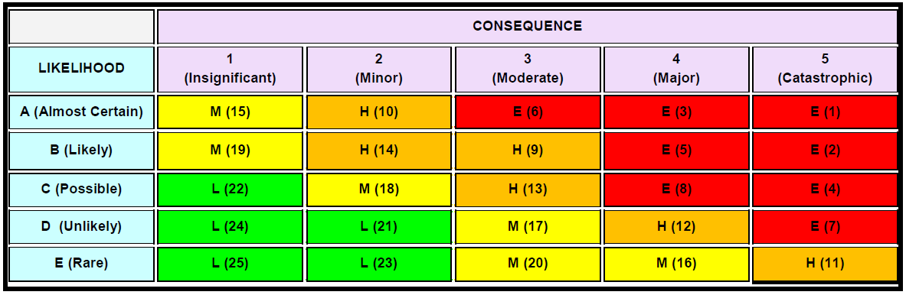

What’s the Point?

We identify hazards and assess the associated risks so that we can work as safely as possible.

Taking time to stop and think through the task and where you are working as a whole allows you to identify the hazards to yourself and others and put controls in place to make sure that you go home safe and healthy every day.

Hierarchy of Controls

When hazards are identified, a combination of controls can be used. We use the hierarchy of controls to do this.
Most
Effective
Less Effective
Eliminating a hazard is always the best option. When that is not possible, you
then move down the hierarchy and choose the most suitable control(s) to use.

- Elimination
- Substitution
- Isolation
- Engineering (e.g. mechanical aid)
- Administrative (e.g. SOP, JSA)
- PPE

Hazard Observations

Report any hazards you find on a hazard report form (HAZOB) and hand it to your supervisor.

The HAZOB is entered into the Corrective Actions Register and is reviewed at site safety committee meetings.

What a Good HAZOB Looks Like
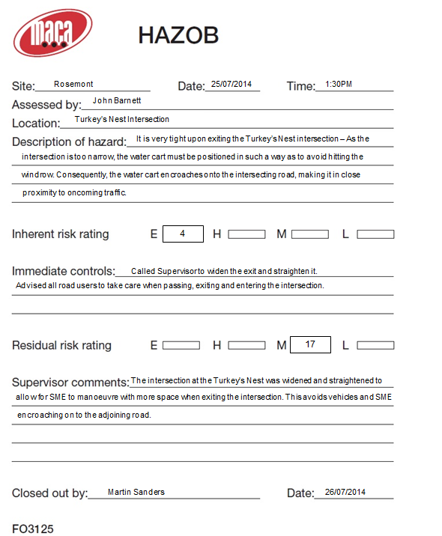

The Supervisor or Project /Alternate should outline the procedure taken to rectify the HAZOB, as this needs to be detailed in the Hazard Register. The words ‘Closed Out’ does not suffice.
Detail as much information in the HAZOB description as you can
When assessing Inherent and Residual Risks, always state the risk rating from the Big Yellow Risk Matrix. Ticking the boxes does not suffice.

Basic Fire

Classes of Fire
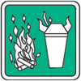

Class A – Ordinary Combustibles
Involves the burning of solids which include: wood, paper, clothing, carpet, material, leather, plastic, vinyl, rubber, cardboard, etc.

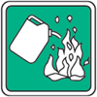

Class B – Flammable Liquids
The burning of liquids or liquefiable solids: petrol (gasoline), diesel, kerosene, alcohol, acetone, turpentine, grease, oil, paint, lacquer, varnish, wax

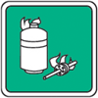

Class C – Flammable Gases
Burning of gases – compressed or liquefied, like: acetylene, butane, ethylene, hydrogen, liquefied petroleum, gas (LPG), methane, propane

Class D – Combustible Metals
Combustible metals in solid, dust and powdered forms, including: aluminium, lithium, magnesium, metal fillings, metal swarfs, sodium, titanium, zirconium
**Class D fires require special purpose extinguishers. Seek expert advice.

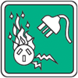
Class E – Electrical Fires
Fires which involve some form of electrical energy.
If you isolate or disconnect the power to this type of fire it becomes one of the four earlier types of fire and should be treated accordingly.

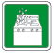

Class F – Fats & Oils
Fires involving cooking oil, grease or fat

Fire Extinguishers

Only fight fires if it is safe and you’ve been trained to do so.

Respond immediately to fire alarms; always treat a fire alarm as a fire until proven otherwise.

Water | Foam | Dry Chemical Powder | Carbon Dioxide
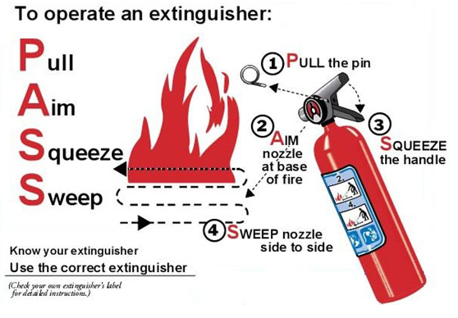
Advantages & Disadvantages

Advantages:
- Quick to action
- Easy to carry
- One person can operate it
- Generally are located close to the hazard

Disadvantages:
- They don’t last long
- They don’t reach very far --- you’ve got to be pretty close to the fire for them to be effective
- They aren’t all the same --- different ones need to be used depending on the class of fire
- They can be unreliable depending on how old they are, when they were last serviced, etc.

What Could Happen if You Use the Wrong Extinguisher?

- Water on an electrical fire can cause electrocution
- Water on a liquid fire may cause it to flare up, spread and cause injury
- Water on an oil or fat fire can cause explosions
- CO₂ on an ordinary combustible (Class A) fire can make it worse, or not completely put the fire out which can allow it to reignite when not expected
- CO₂ on a chemical fire may cause violent explosions

Using a CO₂ Extinguisher

- It can cause cold burns if sprayed on skin so make sure to wear the appropriate PPE and don’t spray others
- It will deplete the oxygen supply in the room so always make sure you have a clear escape route and be aware of wind direction and confined spaces.

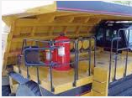
Fire Suppression Systems

Most machines are fitted with a fire suppression system.

Why do we have it?
- Provides the operator the opportunity to evacuate the cab

What parts of the machine will it cover?
- Engine bay

Why is it foam?
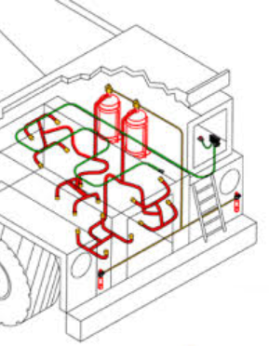
- Foam is the most effective extinguishing medium for diesel/oils/etc. which is what would be catching on fire in the engine bay

Things to Consider Before Fighting a Fire

Some things that you should consider before fighting a fire:

- Size of the fire
- Escape route
- Wind direction
- Other hazards in the area
- Do you have the correct extinguishing agent?
- Do you know what you are doing?
- Is there someone available for backup?

Fire Prevention

Some things that can help towards fire prevention:

- Working safely
- Working within the regulations
- Good housekeeping
- Obtaining a hot work permit
- No fires on days of high fire danger
- Don’t overload power points
- Smokers to correctly dispose of cigarette butts
- Install and regularly test smoke detectors
- Correct chemical storage

Reporting Emergencies

All Emergencies

- Call “Emergency, Emergency, Emergency” over the two-way radio
- Wait for a response from the Supervisor, Project Manager or ERT Officer
- Provide the following details:
  - Your name
  - The location
  - The type of emergency
  - If anyone is injured (number of people only – no names)
- Once all information is passed on you can provide assistance to others if you are trained, and it is safe to do so

Reacting to Emergency Calls

If you are driving a light vehicle (LV) or operating a machine on site when an emergency is called, the following actions need to be taken:

- Pull over to the left hand side of the road
- Activate park brake
- Activate hazard lights
- Maintain radio silence until the “all clear” is given to resume operations

In the Event of a Fire

Sound the alarm --- Raise the alarm to warn others

Evacuate the building --- Remove yourself from danger and move to the emergency evacuation / muster point

Attempt to extinguish the fire --- Only fight the fire if you are trained and it is safe to do so

Remember: Fires start small and quickly become large ones --- your safety and wellbeing come first.

Personal Protective Equipment (PPE)

A blue and white sign indicates that PPE is mandatory.

Designated exempt PPE areas include inside offices, crib rooms, and toilets.

PPE is the last line of defence to keep you safe.

Look after your PPE.

Minimum Site Safety Requirements
- Safety boots – must be lace up
- Sun smart, high visibility (hi-vis) clothing: long sleeved, collared shirt and trousers or jeans
- Gloves and glove clip
- Safety glasses
- Hearing protection
- Hard hat

Additional items may include:
- Welding helmets, jackets and gloves
- Respiratory protection
- Safety harnesses

Uniforms
All labour hire and subcontracting personnel are supplied with protective clothing (i.e. safety boots, shirts and trousers) by the company they are employed through. Other PPE (e.g. glasses, gloves, hearing protection) is supplied by Big Yellow.

For all Big Yellow employees, please refer to SOP6186 – Uniform for more information on the type and number of items you are issued with.

Clothing
- Uniforms should be free from rips and tears and laundered to remove chemical contaminants
- Clothing should be the correct size to cover the body without impeding movement
- Hi-vis reflective vests must be worn such that the reflective tape is visible from both the front and back
- Shirt sleeves must be rolled down at all times
- Shirts should be tucked in to trousers / jeans.

Boots
- Boots should be clean and in good condition
- The upper should be intact and the steel toe should not be exposed
- The sole of the boot should be intact, attached to the upper and have sufficient tread to prevent slipping on smooth surfaces
- Check for damage from chemicals
- Laces should be of sufficient length to enable to boot to be completely laced to the top of the upper
- Eyelets and hooks should be firmly in place and attached

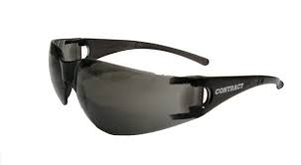
Eye Protection

- Safety glasses should cover the eye area sufficiently
- If personnel have their own safety glasses, they can be worn on site so long as they meet Australian Standard 1336
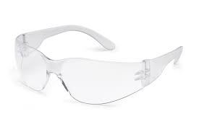
- You will be issued with both a clear and tinted pair of safety glasses.
- Safety glasses must be worn outside of air conditioned areas
- If your lenses are dirty: wash or clean them. Lens wipes are readily available on site
- If your lenses are scratched: replace them
- Other eye protection (e.g. welding helmet, face shield, mono goggles, etc.) will be provided as required.

Hard Hat

- Hard hats have a two-year life span if treated well, the expiry date should be written on the inside of your hard hat on the sticker provided. Use this sticker to write your name as well
- Do not use marking pens, glue or solvents on your hard hat
- Each time you wear it, inspect for defects
- Ensure you store in an appropriate location – don’t leave loose in vehicles as it could become a missile
- If your hard hat has been involved severe impact, replace it immediately
- Caps, hats, beanies and other headwear are not to be worn under helmets.

Hearing Protection

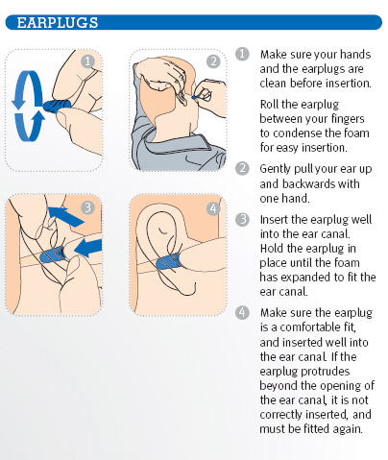
Hearing protection must be fitted correctly to be effective.

The most common type of hearing protection you will find on site is disposable ear plugs. These are an environmental hazard and must be put in rubbish bins (not thrown on the ground).

Disposable ear plugs are intended to be a one-time use item. Ensure you keep several pairs with you should you need to replace them.

Ear canal caps and ear muffs are also available upon request.

Gloves

Gloves must be worn for all manual handling tasks. Everyone is issued with a glove clip so they can be carried on your person when not in use.

Ensure the glove you are using is appropriate for the task. Only certain types of gloves can be used for chemicals. If you are unsure, speak with your supervisor or the HSE Advisor.

Gloves should be intact: check for rips, cuts and burns; check the stitching to ensure glove integrity.

Gloves should be the correct size to cover the hand without restricting movement. Big Yellow supply gloves to suit most employees; however, if you find your gloves are not fitting securely, contact your supervisor and an appropriate size can be acquired.

Respiratory Protection
Masks must be fitted correctly to be effective.

Half masks can only be worn where facial hair does not interfere with the fit.

Big Yellow supply both P1 and P2 half face dust masks.

P1 masks are intended for use against mechanically generated particulates such as asbestos and silica.

P2 masks are intended for use against both mechanically and thermally generated particulates such as metal fumes.

The mask should be intact: check for rips, cuts and tears; ensure the elastic hasn’t been overstretched.

Dust masks should not be shared.

