CONTENTS

1. Purpose 3
1.1 Vehicle Classifications 3
1.2 Definitions 3

2. Licensing 5
2.1 Licensing Requirements 5

3. Vehicle Use 6
3.1 Authorisation to Operate Vehicles 6
3.1.1 Familiarisation 7
3.1.2 Loss of Drivers License 7
3.1.3 Use of Big Yellow vehicles 7
3.2 Pre-Start, Walkaround and Post-Check Inspections 7
3.2.1 Pre-Start Inspection 7
3.2.2 Isolation requirements for Pre-start Inspections: 8
3.2.3 Walkaround Inspections 9
3.2.4 Post Check Inspection 9
3.3 Vehicle Requirements 9
3.3.1 Brakes and Steering 9
3.3.2 Headlights and Flashing Lights 9

4. Communication 10
4.1 Communication Essentials 10
4.2 Two Way Terminology 10
4.3 Emergency Communication 11
4.4 Mobile Phones 11
5. Road Rules 11
5.1 Intersections 11
5.2 Emergency Vehicles 11
5.3 General Road Rules 12
5.4 Giving Way 12
5.5 Speed Limits 12
5.6 “U” Turns 13
5.7 Overtaking 13
5.8 Tailgating – Safe Following Distances 14
5.9 Horn Signals 14
5.10 Breakdowns 14
5.11 Breakdown Recovery 14
5.12 Crests and Ramps 15
5.13 Road Maintenance 15
5.14 Night Driving 15
5.15 Road Signs 15
5.16 Parking 16
5.17 Reversing / Clearance 17
5.18 Temporary Roads 17
6. Vehicle / Pedestrian Interactions 17
6.1 50 Metre Exclusion Zone 17
6.1.1 Accessing 50 Metre Zone 17
6.1.2 Leaving 50 Metre Zone 18
6.1.3 Blind Spots 18
6.1.4 Passengers 19
6.1.5 Passengers Getting onto Equipment 19
6.1.6 Passengers Leaving Equipment 19
6.1.7 10 Metre Zone for Drills 19

6.2 Escorting Unauthorised Personnel and Over Sized Loads 19
6.2.1 Escorting 19
6.2.2 Loads - On Site 20
6.2.3 Oversize Loads 20
6.3 Towing or Pushing 21
6.4 Spotting 21
6.5 Trailers 22
6.6 Blasting 22
7. Road Conditions and Other Requirements 23

7.1 Hazardous Areas 23
7.2 Wet Weather/Roads 23
7.3 River Crossing 23
7.4 Poor Visibility 23
7.5 Dust Suppression 24
7.6 Smoking in Vehicles / Equipment 24
7.7 High Voltage 24
7.7.1 Proximity to Power Lines 24
7.7.2 Contact with Electrical Conductors / Lightning 24
8. Document History 25
9. Support Documentation 25
10. References 25

Purpose

Provide instruction and guidelines to ensure the safe, efficient and productive operation of all vehicles and the safe interaction between all vehicles and personnel.

Where this procedure doesn’t clarify actions to be taken for a task, take all hazards into consideration using a Take 5 assessment and do tasks as safely as possible.
If further clarification is required, ask the supervisor for assistance.

Do not operate any vehicle or equipment that you have not be trained to safely use, assessed for competency and authorised to operate

Vehicle Classifications
Light Vehicles  (under 4.5 tonne) | Sedans, utilities, light vans, four-wheel drives, small trucks
Heavy Vehicles (over 4.5 tonnes gvm) | Explosives trucks, cranes and forklifts, fuel trucks, low loaders, buses carrying more than 12 people, service trucks, mobile workshops
Surface Mining Equipment (SME) | Dump trucks, watercarts, scrapers, wheel dozers, loaders (& IT carriers), graders, excavators, dozers, drills, rock breakers
Heavy Haul Units: | Dump trucks, watercarts, scrapers
Vehicles that Require Escort Procedures (Section 10) | Low loaders (floats), skidsteer (bobcat), forklifts, telehandlers, elevated work platforms
Emergency Vehicles | Sirens and emergency lights must be activated on emergency duty, otherwise they are classified as one of the above vehicles. Includes fire engines, ambulances, police vehicles, emergency response vehicles.

Definitions
Active Mining Areas | - All areas outside office/workshop complex  - All loading and tipping areas – waste dumps, tip heads, stockpiles  - All connecting haul roads and access tracks  - ROM pads  - Any other area where “mining or related works” are taking place
Australian Road Rules | The basis for all road rules and vehicle interactions
Controlled Stop | The operator has stopped the vehicle and as required:  - Applied park brake  - Neutral selected and hazard lights are on  - SME with ground engaging tools (GET) lowered to ground
Fundamentally Stable | Secure state in which Surface Mining Equipment and Heavy Vehicles are parked:  - GET grounded  - Neutral / Park gear applied  - Park brake applied  - Does not need to be shut down or isolated  - Operator has departed the cab to the deck/walkway
Exclusion Zone | - Is a 50 metre radius around any SME  - Is a 10 metres radius around any drill
Driver/Operator | Person who is trained, assessed, deemed competent and authorised to drive / operate a designated vehicle
Physical Access Barriers | Barriers restricting access e.g. windrows, demarcation cones, danger tape
Project Manager | Project / Alternate Manager - as designated on site and all related documents
Safety Breach | Any breach that does not follow procedures, guidelines or direct instruction from an authorised person
Stopping Distance | Distance from the moment the driver recognises the need to stop until the vehicle has stopped
Uncontrolled Intersection | Intersections without “Give Way”, “Stop” or any other instructive sign
Vehicle | If not specifically noted, in this document vehicle means all vehicles and equipment
Wide and Abnormal Load | Any SME / HV wider than the designed road width in the direction of travel.

Licensing

Vehicle operators on a gazetted road must hold the correct Australian License for that vehicle.

To drive a Light Vehicle, a current Australian “C” class manual license is required.

Manual / Automatic licensing specification are also applicable to all light vehicles and trucks

Exemptions from statutory licensing requirements for onsite operation require client written approval

Licensing Requirements

A current Australian National ‘HR’ class manual license is required to operate SME / HV’s on site.

All trucks (excluding dump and articulated), buses and light vehicles require licenses as per the Gross Vehicle Mass (GVM) specifications of the Department of Transport Western Australia

- “C” Class = vehicle with GVM less than 4.5. tonne or is equipped to seat up to 12 passengers (including the driver)
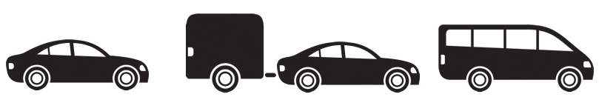

- “LR” Class – vehicle with GVM greater than 4.5 but less than 8 tonne or is equipped to carries more than 12 passengers (including the driver)
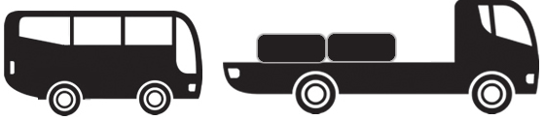

- “MR” Class – vehicle with two single axles and GVM greater than 8 tonne
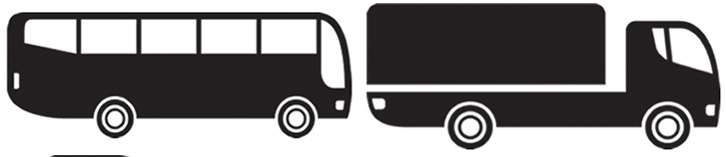

- “HR” Class – vehicle with 3 or more axles and GVM of more than 8 tonne
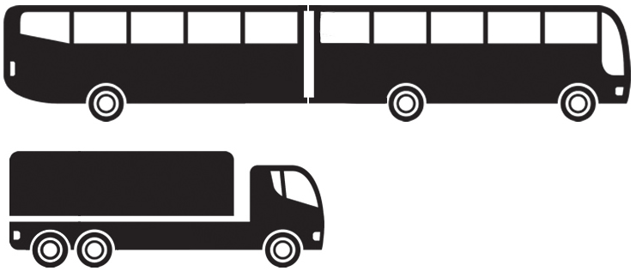
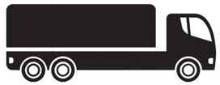

- Buses / Trucks (Converted into Buses) require:

- Current National Licence dependent on GVM of the vehicle
- “F or T” Class Endorsement for carrying passengers when vehicle has more than 12 seats including the driver)
- If “F / T” endorsement is not held and bus is not being driven on gazetted roads and is carrying passengers - then written approval by the Project Manager and the Client is required
- Bus competency

- Under Department of Transport guidelines above, if a person has been deemed competent to operate a truck at a higher level they are competent to operate trucks in the lower classes as per the diagram below:

 | Truck Compliance Applications
License | HR Man | HR Auto | MR Man | MR Auto | LR Man | LR Auto | C Man | C Auto
HR Manual
HR Auto
MR Manual
MR Auto
LR Manual
LR Auto
C Manual
C Auto

- “HR Manual” license – A Mack Highway Truck competency requiring gives competency to operate all trucks in the lower license categories, covering all trucks, buses (with guidelines above considered) and light vehicles
- “HR Automatic” license – applies the same except to automatic trucks only

Vehicle Use

Authorisation to Operate Vehicles

A person must have:
- Verbal authorisation by the Project Manager or Supervisor
- Current required license for that vehicle or written authority from Registered Manager
- Completed relevant site inductions
- Deemed competent to operate that vehicle

Personnel who do not hold current site inductions or permits must be escorted in the pit. The mining supervisor must be advised of all escorted movements on the site.

Private vehicles shall only be driven in the mining area under conditions set out by the Project Manager.

Familiarisation

Persons must be given a familiaristion / re-orientation of the current work area after absence from site for more than seven days or less if the work area has changed such that the traffic management has been altered.

Loss of Drivers License

Any person who’s driver’s license is cancelled, run out or suspended, must inform their Supervisor immediately and cease operating all vehicles and equipment, until directed to continue or other duties. Failure to disclose loss of licence may result in disciplinary action and possible termination of employment.

The Project Manager in consultation with the Client’s Registered Manager will determine whether an exemption (confirmed in writing) will be made to allow the employee to continue driving / operating.

Use of Big Yellow vehicles

Company vehicles may be used outside the normal work environment for:
- Shift change requirements
- Private use - only with approval from the Operations Director.

Security of vehicles retained overnight / weekends is the responsibility of authorised person.

Unauthorised / inappropriate use of BYM vehicles will result in disciplinary action.

Hire vehicles shall be treated as company vehicles.

Infringements issued whilst using the company vehicle are the responsibility of the driver.

Pre-Start, Walkaround and Post-Check Inspections

Pre-Start Inspection

A Pre-start inspection will be done on all vehicles at the commencement of each shift or as the equipment is required for that shift.

Pre-Start Forms include:
- FO7117 – Pre-Start Checklist - Tyres Handler
- FO7119 – Pre-Start Checklist – Equipment
- FO7157 – Pre-Start Checklist – Light Vehicle

Pre-Start checks cannot be conducted on loaded Dump Trucks. A walkaround inspection can be done whilst maintaining 3 metre from the truck.

No Light Vehicle shall be driven/operated until driver is satisfied the following are working and in good order. Complete pre-start inspection check list:

- All lights including, indicators, brakes, head lights, flashing and any warning lights
- Two-way radio
- Steering and brakes
- Tyres, spare tyre, jack and tool kit
- Horn
- Flag pole with flag
- Fire extinguisher

Isolation requirements for Pre-start Inspections:

- All vehicles – as per SOP3026 - Isolation
- Light Vehicles – If no isolation point is in place, first or reverse gear selected, park brake applied and keys removed from the ignition.

Procedure for All Vehicles and Equipment

1. Isolate as per SOP3026
2. Undertake pre-start inspection using and completing appropriate check list
3. When inspection is complete, de-isolate as per SOP3026
4. After starting engine, check for correct temperatures, pressures, fuel / oil indicators as stated in the vehicle or equipment operational guide.

Actions

- Minor faults and defects – report to the Supervisor and note on pre-start
- Defects reported must be noted on the Operators Daily Checklist and transferred to the Daily Plant Defects Listing by the Workshop Supervisor.

There are two sections to the prestart form for SME / HV’s:

- Category “A” Faults – if any items fail - the vehicle will be tagged “out of service” and reported to the supervisor
- Lower section – if any items fail - the vehicle can go to work if deemed safe to do so by the supervisor

If any defects or faults occur during the shift, immediately report to the Supervisor who will report to the Workshop Supervisor

Faulty vehicles should not be moved without Workshop Supervisor permission.

No person shall operate any vehicle they consider to be unsafe

Single use Pre-Start forms should be completed and passed to the supervisor at the first break. Weekly forms should be kept in the pre-start book and handed in at end of the scheduled week.

Operators should familiarise themselves with the specifics details of pre-starts for vehicles and equipment, available in the training manuals.

Walkaround Inspections

When a pre-start inspection has already been conducted in the current shift, personnel taking over a vehicle should do a walkaround inspection for any obvious faults or damage by circling the vehicle without entering the footprint (which would require isolation). Report all defects and damage.

Post Check Inspection

Whenever personnel are leaving equipment, they must do a Post-Check inspection by walking around the vehicle without entering the footprint (which requires isolation) checking for possible damage and faults that may have occurred. Report all defects and damage.

Vehicle Requirements

Brakes and Steering

All vehicles shall be equipped with brakes capable of effectively stopping and holding that vehicle, fully loaded under any working conditions

Brake and Steering tests should be done on all vehicles prior to leaving parkup areas (as per requirements of individual equipment SOP’s)

Headlights and Flashing Lights

Vehicles shall have headlights capable of illuminating the way ahead for a minimum of 60m during the hours of darkness and clearly visible taillights to the rear of all vehicles.

Headlights and flashing lights must be turned on at all times when operating.

Vehicles in Active Mining Areas:

- Headlights and flashing lights must be left on when temporarily unattended e.g. supervisor checking RL’s
- If left for an extended period of time, park in a safe location and turn all lights off
- Where practicable always park at a designated “go-line”

Flashing lights must be turned off when travelling on public roads.

Communication

Positive communication is essential between equipment and personnel to ensure there is no confusion about actions being taken.

All vehicles and personnel who enter Active Mining Areas must have working radio communication set to the correct channel

Positive communication should be used with good planning, removal or reduction of risk, clear instruction, understanding and vigilant supervision.

Personnel should not only rely on positive communication for safe work. Individuals are required to ensure they use their own eyes to check their proximity to other equipment and personnel.

Communication Essentials

- Ensure correct two way channel is set for the area and volume is adequately set
- If out of a vehicle, personnel must carry a hand held radio. In a group, the person in control of the group will remain in radio contact at all times
- Be specific when referencing location
- Speak clearly and be straight forward
- Use equipment/asset numbers or call signs when communicating
- Do not use of personal names
- Swearing and bad language is not acceptable
- Clicking of handset is not acceptable, responses must verbal
- Wait for confirmation, do not assume messages has been heard
- Keep transmissions brief and to the point
- Be aware of other people talking and don’t cut over
- Hold the hand piece within 10cms directly in front of mouth when speaking
- Before speaking - hold hand piece button in for 2 seconds
- Place hand piece on hook when not in use
- Emergency silence shall always be observed, if you aren’t directly involved
- Observe Radio Silence following a blasting notice being given
- Be familiar with the “Emergency Call Up” procedure

Two Way Terminology

- Receiving – “yes I hear you, go ahead”
- Copy – “message understood, got that”
- Standby – “please wait”
- Emergency called three times – “Help required”
- Say Again – “please repeat”

To call another vehicle/individual do the following:

Call equipment / asset number or call sign followed by senders call sign:

- e.g. DT12 (being called), LV53 (making the call). The correct response is “DT12 receiving”
- e.g. Bravo1 (being called), DT59 (making the call). The correct response is “Bravo1 receiving”

In vehicle interaction including overtaking, clear and proper verbal communication is essential

- If overtaking:

  - Grader # on “state location”, permission for “vehicle” to overtake on your “left / right”.
  - Grader responds - Grader 7 copy, clear to come past OR Grader 7, hold your position, “state reason”
  - When it is clear – “vehicle” you are now clear to come past Grader 7 on your “left/right”.
  - Vehicle Responds – copy that Grader 7, coming past on your “left/right”

Emergency Communication

For emergencies, personnel are required to call up on their operating radio channel:

“EMERGENCY, EMERGENCY, EMERGENCY”

On being answered, state:

- Your name, location, and the location of the emergency
- The nature of the emergency, e.g. fire, vehicle accident
- If persons are involved, trapped or threatened, how many
- Whether fire is likely to result
- Standby for instructions
- Give assistance if trained and if safe to do so

Note: Do not state the names of personnel involved over two-way radio.

All other work related radio traffic must cease immediately.

All vehicles (not involved in the emergency) must:

- Pull over to the left hand side of the road as soon as is safe
- Apply park brake
- Activate hazard lights
- Maintain radio silence
- Await further instructions.

Mobile Phones

Refer to SOP3023 use of mobile phones and electronic devices.

Personnel who are provided with mobile phones as part of their work are not permitted to use them whilst the vehicle they are driving is in motion, unless the vehicle is fitted with hands free equipment.

Personnel are required to abide by the Client’s rulings for the use of mobile phones onsite

Road Rules

Intersections

Will have traffic control signage, as laid out in the Traffic Management Plan

Emergency Vehicles

- Give way to emergency vehicles (ambulance, fire, police and site emergency vehicles) when they are displaying emergency signals and sounding alarms
- Emergency vehicles with red & blue flashing lights operating, may disobey traffic signs with caution.

General Road Rules

- Australian road rules and signage are applied on site. No vehicle has precedence over any other except in emergency conditions
- Light vehicles should follow heavy equipment down and up ramps maintaining 50m behind
- Down-hill traffic has Right of Way over up-hill traffic – except when entering a confined area, such as a drop cut where two trucks cannot fit and alternate traffic management plans have been established
- No person shall approach within fifty (50) metres of SME / HV unless radio contact has been established and permission given by the SME / HV operator.
- Drive to Conditions - If conditions are wet, the visibility or road/ramp conditions are poor, then slow down and proceed safely. Advise your supervisor and other operators as to the change in conditions. Light vehicles to engage 4WD

- When light vehicles are not following other vehicles - they should be driven in a road position so they can be clearly seen by equipment entering the roadway.

Giving Way

Do not flash head lights to indicate giving way

If giving way - vehicles must come to a stop, apply hazard lights
and use positive radio communication with the other vehicle

If communication isn’t acknowledged, hold position until response received. Do not assume your message has been received and understood without confirmation.

Speed Limits
 | Mobile Plant | Light Vehicle
Access Roads as posted | N/A | 40km - 70km/hr
Pit Haul Roads | 40km/hr | 40km/hr
Pit Floors (dependent on conditions) | 20-40km/hr | 20-40km/hr
Compound & Workshop Area | 10km/hr | 10km/hr
Camp Car Park | N/A | 10km/hr
Ramps | 30km/hr | 30km/hr

Speed limits are managed through the Traffic Management Plan and may differ between sites. Changes must be done through the change management system and site specific procedures.

“U” Turns

Ramps – vehicles or equipment are not permitted to do “U” turns on ramps.

Light vehicles may undertake “U” turns on haul roads if there is clear vision in each direction and it is safe to do so.

SME / HV’s are not permitted to do “U” Turns on haul roads. If required to change direction, they should find a location off the haulroad where they can turn around on their onside for clear visibility

Overtaking

Vehicles that must not be overtaken include:
- Active emergency vehicles
- Explosives trucks - Delivery / MMU
- Light Vehicles
- Service Trucks
- Moving heavy haul units - dump trucks, scrapers and watercarts
- Equipment under tow, without clearance from towing party
- Escorted vehicles or equipment

Overtaking can be hazardous and must be executed with caution at all times, overtaking is the responsibility of the overtaking operator

Overtaking Process
Heavy haul units, light vehicles, light trucks and service trucks may overtake slow moving vehicles (i.e. dozers, graders, loaders, wheel dozers, excavators, drills), provided they: -

- Are not within 50m of an intersection
- Overtaking operator can clearly see that there is no oncoming traffic
- Overtaking operator has radioed vehicle being overtaken and received positive acknowledgment “Vehicle #, confirming it is clear and safe to overtake on my right hand side”
- Overtake on the right hand side (the exception - grader if working on right hand side. Clearly communication actions. Avoid driving over graded windrows)
- Pull out and overtake only if it is safe to do so

See Section 6.2 for correct communication practice

Overtaking Stationary / Broken Down Heavy Haul Units
Heavy haul units, light vehicles, light trucks and service trucks may overtake stationary/broken down heavy equipment and vehicles by the above procedure if:

- Vehicle has hazard lights activated
- Is approached with caution
- Overtaking operating is watching out for personnel attending the stationary vehicle
- It is safe to pass
- Speed has been reduced 20 kph

Overtaking on Ramps
Heavy haul units and light vehicles/trucks and service trucks may overtake slow moving equipment (working grader, dozers, drills, excavators, wheel dozers, loaders) travelling up or down ramps if:

- The equipment being overtaken moves as far to the left hand side as possible
- Comes to a complete stop to allow overtaking vehicle to overtake safely

Tailgating – Safe Following Distances

All vehicles must maintain a distance of at least fifty (50) metres when travelling behind other vehicles.

When following a dump truck, light vehicles must travel so they can be seen in the view of the trucks rear view mirrors.

Horn Signals

Horn signals must be used to signify start up or movement of heavy equipment.

- 1 Blast and pause (5 secs) - about to start engine
- 2 Blasts and pause (5 secs) - about to move forward
- 3 Blasts and pause (5 secs) - about to reverse.

This doesn’t apply to dump trucks in the load and haul circuit or SME’s / HV’s undertaking mining operations.

Breakdowns

Light vehicle breakdown:
- Pull off to the side of the road (if possible)
- Turn front wheels to the windrow, apply the hand/park brake
- Advise Supervisor and all other personnel by radio of equipment and location
- Activate hazard warning lights
- Leave parking lights on if in darkness (if possible)
- The flashing light should remain on.

SME / HV breakdown:
- Place / point the SME/HV to the wall or windrow, without causing damage, then apply park brake
- Follow “breakdown” procedure as above
- Operator must remain seated at the controls until assistance arrives unless in personal danger or directed by a Supervisor
- If on a ramp or incline - supervisor must secure the truck using a temporary bund all the width of the SME / HV and not less than half the height of a truck’s tyres on the down slope. The temporary bund must be completed before any person approaches or investigates the breakdown.

Breakdown Recovery

Broken down vehicles will be parked, have hazard lights illuminated or warning signs and cones placed around the vehicle to ensure the safety of personnel attending. No person may work where they are at risk of being hit by passing traffic until controls are put in to eliminate this hazard.

Vehicles are to be towed from roads if repairs are substantial or cannot be conducted safely.

If it is determined that the vehicle is required to be recovered, the following steps must be taken:
- Recovery to be performed under supervision in conjunction with workshop personnel using a JSA
- Determine appropriate towing equipment (slings, tow bars and safe rated shackles). Do not drag tow ropes or slings
- Notify all personnel by two way radio
- The JSA will determine if it is necessary to close the route to other traffic
- Where practicable move the vehicle at shift change to minimise interruption
- Use a separate radio channel to allow uninterrupted communication for those involved.

On completion give the supervisor to give an “All Clear” on the two-way.

Crests and Ramps

Road crests shall be approached with caution. Operators shall keep to the far left.

Road Maintenance

Operators shall report to their supervisor and other operators any obstructions, spillage or deterioration of road conditions that could impact operations.

Supervisors to remedy as soon as possible.

Night Driving

All vehicles used at night must have fully operational and effective headlights and parking lights.

All personnel must drive within the limitations of vehicle headlights and show consideration to others by use of the low/high beam.

“You must be able to see and your vehicle be seen”.

Roads used at night must have adequate lighting or delineation.

Road Signs

The road signs used are:

- Regulatory Signs - Give specific instructions (red, black and white)
- Warning Signs - Warn of hazards (black and yellow)
- Guide Signs - Advise on directions, locations, distances and routes
- Special Purpose Signs and Devices - Warn of temporary hazards and conditions.


Ensure fallen/dirty signs or delineation are cleaned/reinstated as soon as practicable and if unsafe immediately. Operators observing fallen or dirty signs are to inform their Supervisor as soon as possible.

To pass through cones that are not around a drill and blast area, permission must be obtained from the supervisor managing that area e.g. production, maintenance, crushing.

Parking

Light Vehicles
- To be reversed parked unless a humped parkup area is positioned that allows for drive through access
- In Active Mining Area, be parked so they can be driven away in a forward direction
- Light vehicles should not enter SME / HV go-lines unless attending to maintenance requirements. Always park on onside in view of cab

All Vehicles

Operators must use pedestrian paths to approach and leave their vehicles.

Except for emergencies or breakdowns, vehicles shall not be parked:
- On a haul road or ramp
- Within 10 metres of a pit wall or dump faces
- On an incline
- In the path of dump trucks
- Within 50 metre of SME / HV’s except under normal production queuing for dump trucks

The following applies to parking of SME/HV’s:
- Parking of heavy haulage equipment should be in a humped parkup area
- If a humped parkup area is not accessible, park on flat ground (where possible) and chock tyres. Avoid the use of the ‘v’ drain to park the front wheels of equipment.
- Park to enable driving off in a forward direction
- Heavy haulage equipment will be parked left to right with a minimum of three (3) metres between
- If parking on slope unavoidable – permission is required from the supervisor. Turn wheels to windrow, select neutral/park, apply park brake, stop engine. Tyres must be chocked
- Tracked equipment must have park brakes and control locks applied, be parked on level ground with GET lowered to the ground
- Rubber tyred equipment with GET must have GET lowered to ground with parking gear and brakes selected
- Turbo timer’s should be used. If not functioning, engine should be idled down and shutdown before leaving the equipment.

NOTE: Parking requirements do not apply when waiting to access single lane sections of a haul road or ramp.
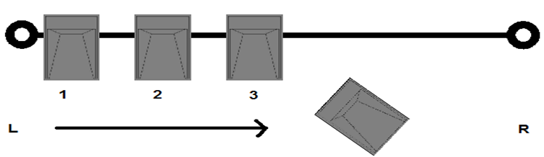

Night Time Parking

When parking in pit at night, use a designated and well lit area.

Reversing / Clearance

- Operators must ensure they operate with adequate clearance
- No vehicle shall pass behind a dump truck preparing to back for loading or tipping
- Reversing should be avoided whenever possible (except in load and haul process) but if necessary requires the use of a spotter (SOP4219)

Temporary Roads

Temporary roads should be used with caution. JSA’s should be undertaken where requirements are outside of TMP.

Vehicle / Pedestrian Interactions

50 Metre Exclusion Zone

No person or vehicle is approach within fifty (50) metres of a working HV. Exception are dump drucks approaching an excavator for loading. Ancillary equipment grading, dozing, watering should call up prior to entering the exclusion zone.

Where a vehicle or person is required to approach a working SME/HV for access or work, then permission must be obtained from the SME operators.

Always clearly communicate your intentions and wait for a response.

Where practicable avoid entering any working area.
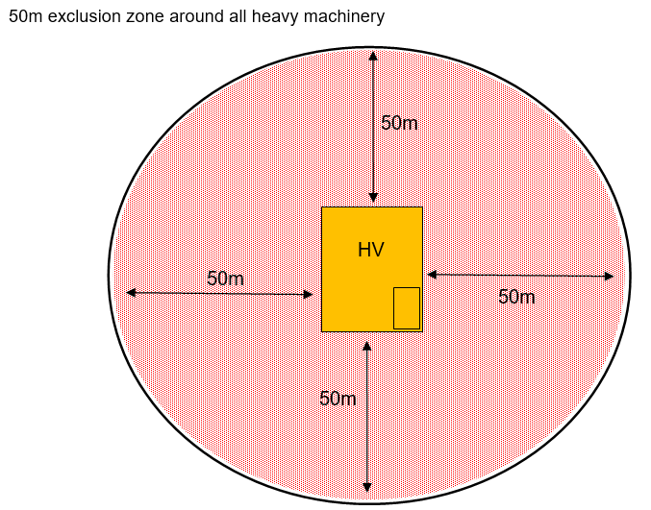

Accessing 50 Metre Zone

Maintain fifty (50) metre clearance until radio contact has been made with the equipment operator and verbal permission given to enter the zone.

- Do not access zone until equipment has ceased work and grounded GET creating a “fundamentally stable” condition
- Equipment must be approached from the front in a position clearly visible from the operators cab
- The equipment operator cannot recommence operations until they receive verbal and visual confirmation that ALL vehicles and personnel have left the 50 metre zone
For maintenance / refuelling / personnel change out or collection:
- Equipment operator must ensure equipment is correctly parked and shut down for maintenance / refuelling
- Operators must leave the equipment before maintenance or refuelling commences
- Upon completion, operator must remain outside of equipment cab until vehicle has left the 50 metre exclusion zone
- If testing of equipment is required, maintenance vehicles must be relocated to outside 50 metres.

Leaving 50 Metre Zone

When leaving a fifty (50) metre zone, personnel must advise by positive two-way radio when they have done so.

It is the equipment operator’s responsibility to ensure that the fifty (50) metre zone is clear of vehicles, personnel and other equipment before moving or commencing operations.

Blind Spots

All personnel must be familiar with equipment “blind spots”.

Dump truck have large blind spots.

When parking near heavy equipment the vehicle must always be positioned to the onside of the equipment and in a position that can be seen from the cab and positive communications must be established

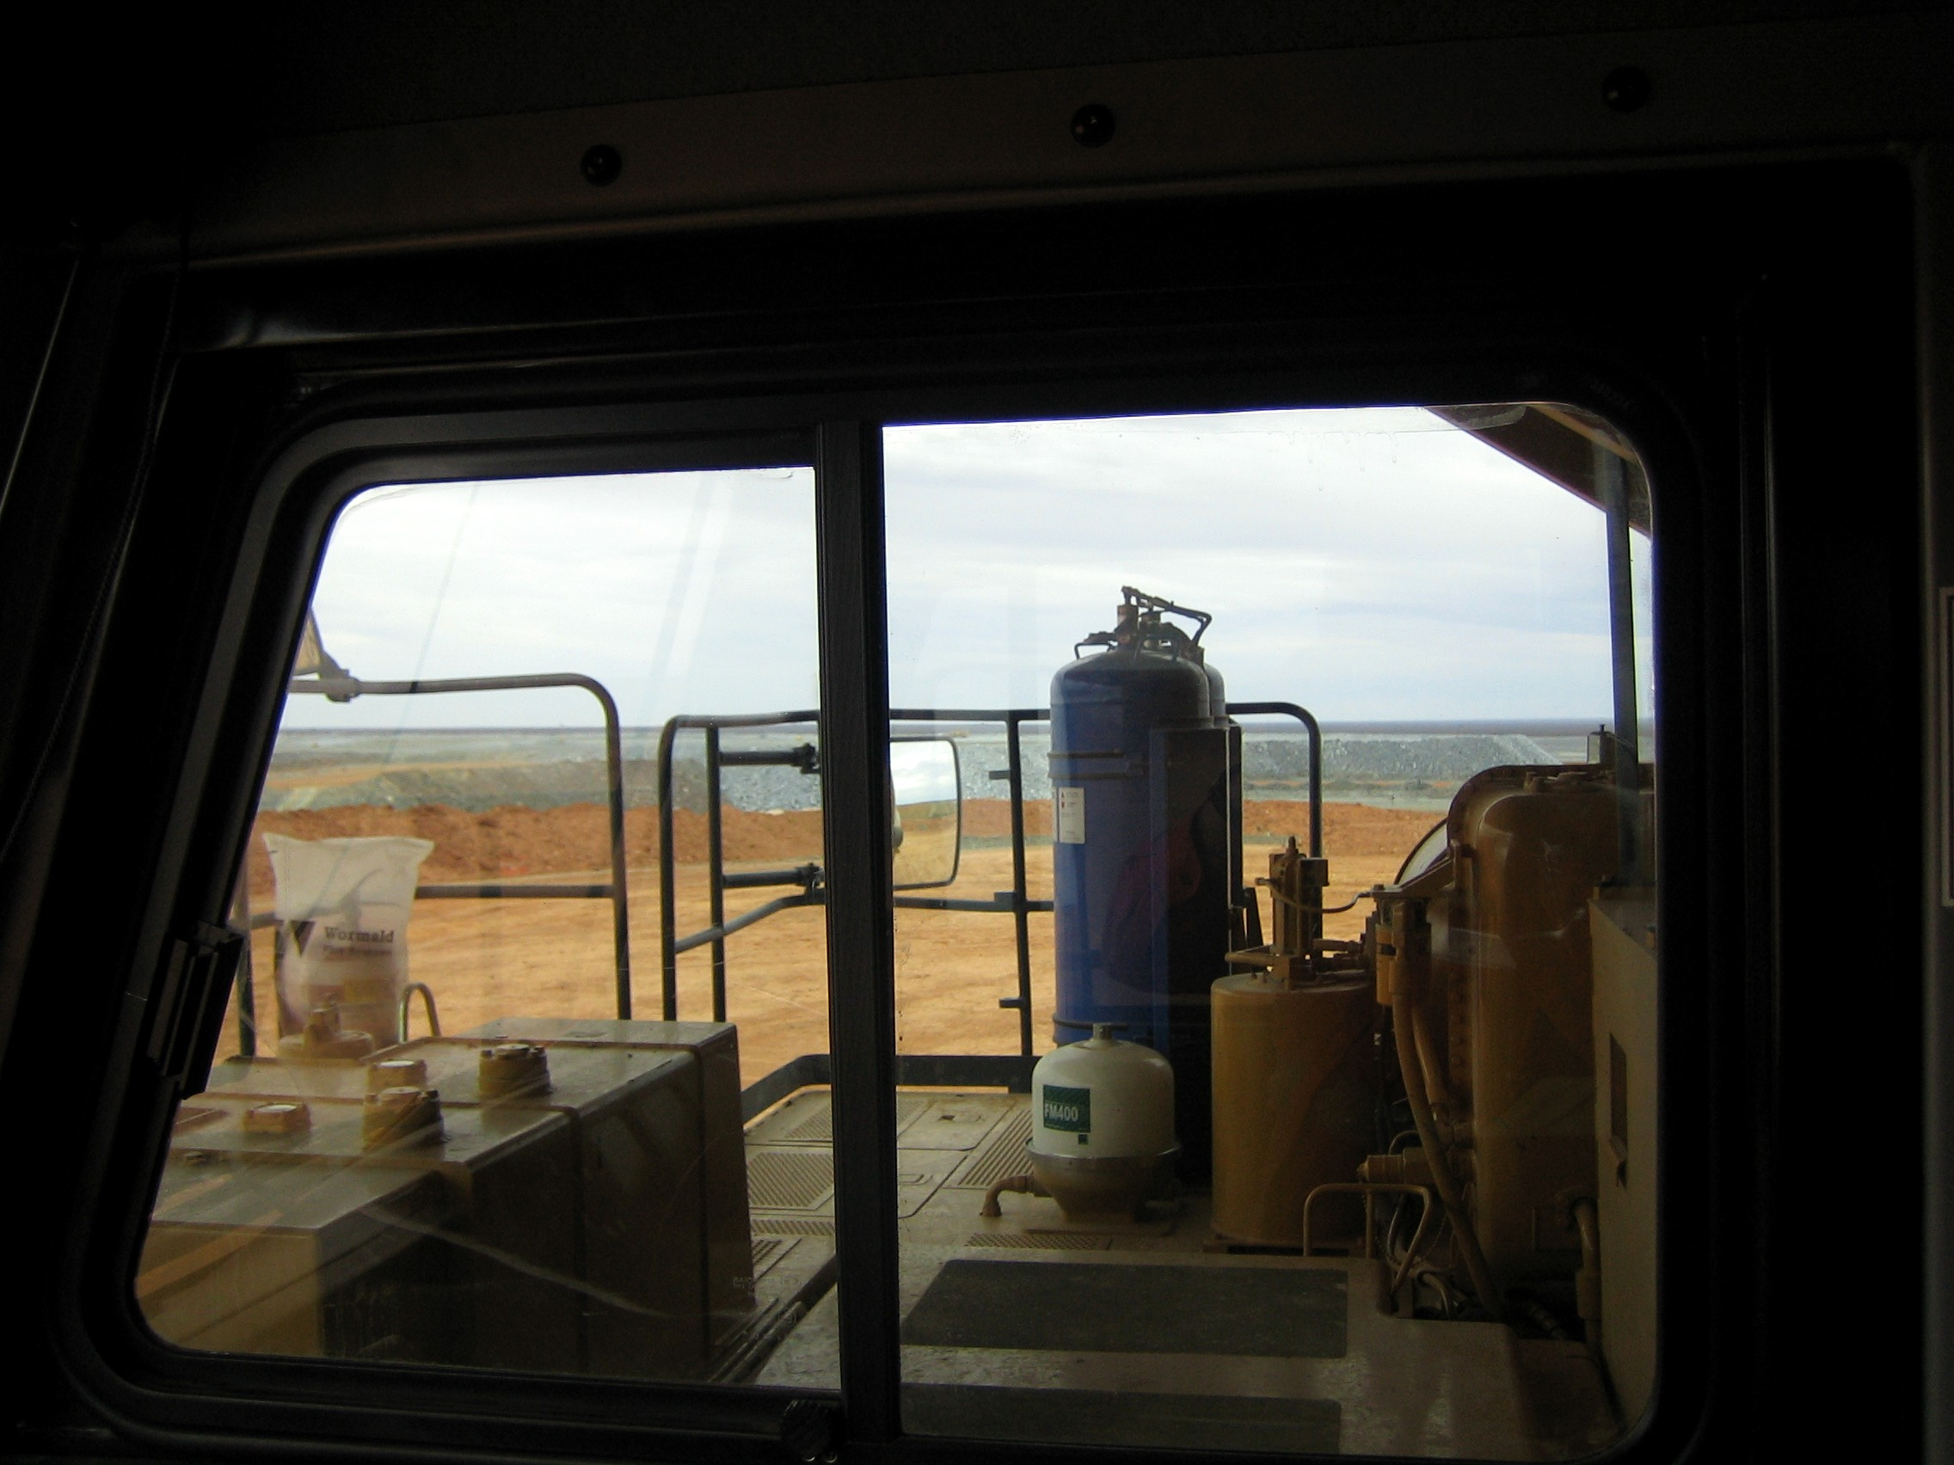
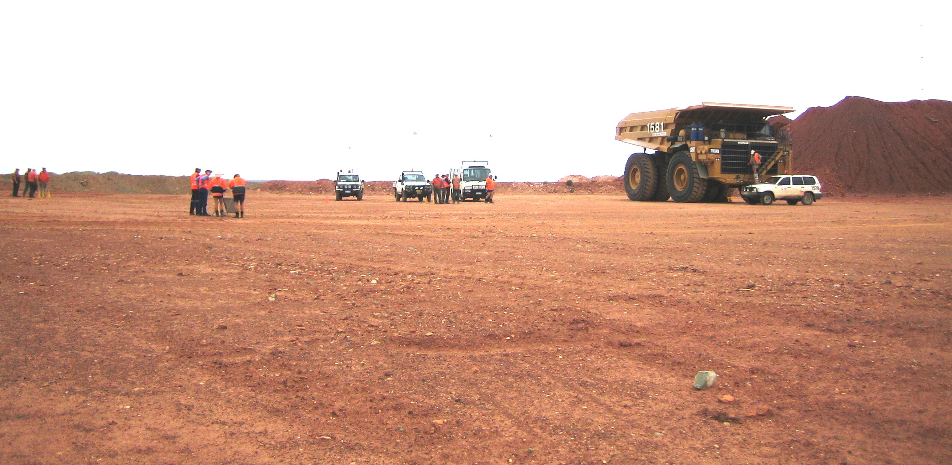
Do not park
within 50 metres of equipment,
either stationary or operating except under normal production queuing for dump trucks.

From operator seat What is actually outside

Passengers

Heavy vehicles shall not carry passengers unless:
- A seat and seatbelt are available
- Permission has been granted by a Supervisor
- Training is in progress

No person shall climb on or off any moving/operating equipment.

Passengers Getting onto Equipment

Whenever a passenger is accessing or leaving equipment, the operator must:
- Make equipment “fundamentally stable” (select neutral, apply park brake, lower ladder – when applicable)
- Step out of cab before indicating to passenger to access the equipment
- Return to the cab with passenger.

Passengers on ground must wait in a safe location in direct sight of the operator. Once operator has left the cab and given the passenger visual acknowledgement, only then can they commence boarding the equipment.

Passengers Leaving Equipment

When passengers are leaving the equipment, the operator must:
- Make the equipment fundamentally stable
- Depart the cab with the passenger
- Remain outside of cab until the passenger has moved clear of the equipment and has given visual acknowledgement that they are clear.

10 Metre Zone for Drills

A ten (10) metre zone applies to all drill rigs and before approaching a working drill rig, personnel must:
- Maintain ten (10) metres clearance until positive radio communication has occurred and the drill rig has ceased operating by:
- Disengaging the hammer
- Disengaging the rotation and feed to the neutral position
- Draining stored energy by opening the drill air valve
- Place the drill / tram selector in neutral (rigs with 3 position switch) or place the drill / tram selection in tram (rigs with 2 position switch)
- The operator of the drill has exited the cab

Escorting Unauthorised Personnel and Over Sized Loads

Escorting

Escorting is required for:

- Personnel who have not been inducted or do not hold required licenses/competencies to operate within the Active Mining Area
- Vehicles that have not been approved through workshop inspection process and are compliant with procedures.
- Vehicles being driven in the Active Mining Area which include:
- Oversized loads e.g. floats
- Slow moving
- Small vehicles e.g. skidsteers, forklifts, elevated work platforms, telehandlers
- Not normal minesite vehicles e.g. buses (especially with non mining drivers)
- Vehicles that don’t meet site vehicle criteria
- Being driven by personnel who do not hold a Pit Permit, such as fuel and explosive deliveries.

- Personnel doing escort duties must have authorisation from Project Manager.
- If escorted vehicle has an overhanging load a following escort vehicle should be used.
- Escorted vehicles with only one escorting vehicle (in front) should have a caution sign attached at the rear of vehicle.
- A thirty (30) metre distance must be maintained between the escort and escorted vehicles
- Hazard lights should be activated on all vehicles involved in the escort.
- Escorting vehicle operators must ensure that care is taken not to be separated from their escort in crossing haulroads. All vehicles must follow traffic control signs.

The escorting vehicle operator must inform all personnel:

Attention all Personnel

“LV## ” is escorting “equipment” from “location” via the “haulroad” and finishing at “location”
Please be aware and take caution

At the conclusion of the escort – Attention all Personnel, escort is now complete – thankyou.

Loads - On Site

Drivers must ensure that vehicle loads are secure and safe to transport through physical tie down restraint or by design of compartment for load

Loads that project beyond the vehicle by more than 1.25 metres shall be flagged and a light vehicle shall escort the vehicle.

Where a load on a float exceeds the sides of the trailer a formal JSA shall be conducted and must consider the risks associated with loading, driving and unloading.

Any mobile equipment which impedes the flow of traffic due to physical size or speed must have an amber flashing light and be escorted by an escort vehicle.

Oversize Loads

- Oversize loads shall have a highly visible marker on the extremities of the load
- Written approval must be given by site electrical supervisor prior to oversized loads passing under power lines
- Approval must be obtained from the relevant authority prior to oversize loads crossing or using gazetted public roads
- Oversize loads moved at night shall have the extremities of the load illuminated
- Any loading and unloading at night should be well illuminated.

Towing or Pushing

Towing a disabled vehicle shall be done under supervision of the Project Manager, Workshop Superintendent or their nominee and after a JSA is approved

- Rigid bars shall be used for all towing of wheeled vehicles except in bogged positions
- Chains shall not be used for towing
- Inspect and ensure wire or continuous fibre slings that are rated for the weight of the vehicle are in good condition. Gloves are to be worn while handling wire ropes.

Equipment must not be used to push start other vehicles. Pushing of vehicles must only be conducted under the direction of the Supervisor after the completion of a JSA.

Spotting

A spotter is required in the following instances:

- Machinery entering or leaving the workshop
- When reversing dump trucks
- When visibility is compromised
- When hazards are present
- At any time there is potential for collision with surroundings.

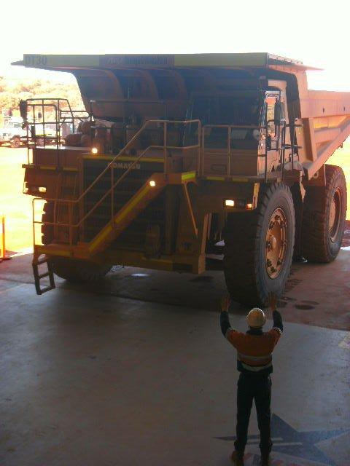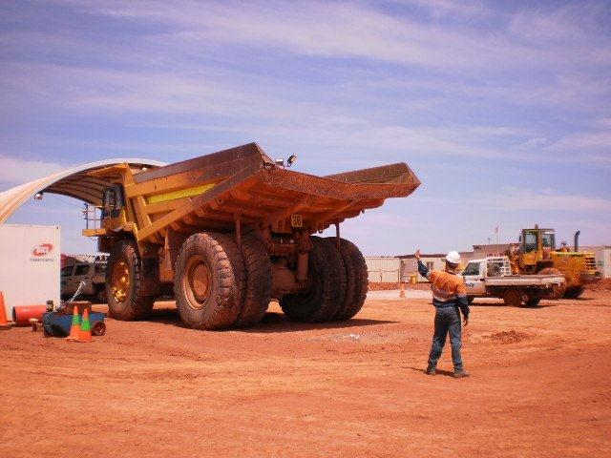

Trailers

Trailers shall be mechanically sound at all times, i.e. drawbar, running gear, lights and tyres shall be in good order. Trailers shall form part of the equipment inspected on site using FO4262 – Lighting Plant & Trailer Defects Checklist. LV drivers are responsible for doing a pre-start check on a trailer prior to towing. The towing vehicle shall operate within its rated towing capacity and tow nothing heavier than its own weight.

Trailers must only carry their rated weight capacity. Shall have two heavy duty safety chains permanently attached to the drawbar which must be secured to the towing vehicle before. An appropriate safety pin must be installed and used with the safety catch at all times.

Maximum speed when towing shall be determined by posted speed limits and road conditions. Particular care to be taken when towing over uneven/broken surfaces.

Trailers to be used on public roads must be licenced.

Four-wheel drive shall be engaged before towing in a pit area.

Trailers shall be constructed and maintained to Australian registration standards.


Blasting

Access to an area being prepared for “blasting” must be authorised by the Shotfirer (as per SOP4101 – Blasting). Blasting areas are barricaded with yellow cones and warning signs are placed on entry roads to the shot.

Access to an area being “drilled” must be authorised by the Drill & Blast Supervisor or the Drill operator.

Care should be taken not to damage holes. These areas are barricaded with orange cones.

Equipment not used in the charging process is not allowed within 8 metres of a charged blast hole.

Blast boards are located at the entrance to Active Mining Areas and at offices and crib rooms and show the date, time and blast location.

Blast information is also provided to personnel at pre-start meetings.

Prior to blasting, a siren will be activated by the blast controller indicating that blasting is about to commence.

No vehicle or personnel is allowed past a blast guard during blasting operations. The “all clear” will be announced over the radio when it is safe to proceed.

Road Conditions and Other Requirements

Hazardous Areas

No vehicle shall be driven into any area that has hazardous ground conditions. Hazardous conditions must be reported to the Supervisor immediately. If in doubt ask.

Wet Weather/Roads

Operators should drive to conditions at all times and must inform their supervisor and other operators if weather conditions, visibility or over watering may compromise safety. If driving conditions deteriorate then reduce speed and ensure you retain full control of your vehicle at all times.

When driving under wet or other poor conditions then:
- Avoid driving unless necessary. The less traffic on wet roads the quicker the roads recover
- Reduce speed and increase distance when following other vehicles
- Engage four-wheel drive on wet roads improving stability, traction and steering
- Avoid sudden braking, steering or acceleration
- Stay at least 50m behind when follow operating water carts.

River Crossing

Drivers/operators of vehicles must not attempt to cross running or standing water or if the level exceeds the following depths. For further information see FO6359A – 4WD Operator Manual
- 4WD Light Vehicles – 0.5 metres
- If depth unknown
- Heavy Vehicles – 1.0 metre
- During adverse weather conditions, creeks/rivers can rise rapidly. Vehicles must not enter any creek/river
- Always consider your return journey where conditions may have deteriorated.

Do not tow light vehicles through water greater than 0.5 m deep.
If a vehicle stalls or becomes stuck crossing the river/creek, radio immediately for help. If it is safe to do so, walk to the closest river/creek bank and wait for assistance.

If a vehicle has to be parked up due to high water levels, ensure that the vehicle is parked in a safe location well away from the embankment and rising water.

Poor Visibility

Should visibility reduce (less than 100 metres), by fog, heavy rain, dust, you should:

- Proceed with caution if unsure stop but only when safe to do so.
- Keep your lights switched on
- Slow down to a safe speed capable of stopping quickly and avoiding other vehicles
- Inform your supervisor and other operators.

Dust Suppression

All road users are responsible for reporting excessive dust conditions.

Dust Suppression shall be undertaken as per SOP4206 – Operation of Watercart and FO6357A – Watercart Operating Manual

Smoking in Vehicles / Equipment

Smoking is not permitted in any company owned or operated vehicle or equipment.

High Voltage

Proximity to Power Lines
No heavy equipment or vehicle may be operated or driven within the ten (10) metre powerline corridor (10 metres each side, below and above power lines).

When passing under and moving in the vicinity of power lines, a minimum clearance of 4 (four) metres must be maintained.

If it is necessary to encroach on these minimum clearances a JSA is required.

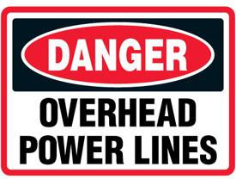
Before work can be conducted within 10m exclusion corridor, then:
- A permit is required for work within 10m of all overhead power lines
- Operation is in accordance with the permit conditions
- Control measures must be clearly identified, communicated to all parties involved.
- A JSA must be completed.

Contact with Electrical Conductors / Lightning

Persons in vehicles that come into contact with an electrical conductor or lightning where the vehicle is immobilised, must:

- Do Not try to exit the vehicle
- Use mine emergency procedures
- Warn all personnel to stay clear, and await for support
- Not touch any conductive material in the vehicle
- Not touch any electrical conductor
- Not operate the controls

Support Documentation

This standard is in alignment with the requirements of:

- FO4262 – Lighting Plant & Trailer Defects Checklist
- FO6357A – Watercart Operating Manual
- FO6359A – 4WD Operator Manual
- SOP1457 – Change Management
- SOP3012 - PPE
- SOP3026 – Isolation
- SOP4101 – Blasting
- SOP4206 – Operation of Watercart
- SOP4227 – Traffic Management
- All SOP’s associated with Vehicles and Equipment under Section 4.2 in the Management System

For information on supporting reference material refer to FO1430 – Legislation and Other Requirements.

References

- Mines Safety and Inspection Acts and Regulations (Western Australia)

Document History

Date &  Document Version | Changes Made | Editor
March 2021 | Document Created | M Wallace
25 May 2021 | Update to license requirements clarifying HR for SME/HV’s | K Muir

